## Backup and Recovery

**Lab Time**: 45 minutes

**Lab Folder**: C:\Student\Labs\14.Backup

**Lab Overview**: This lab will walk you through the process of backing up a site using PowerShell and cover the new unattached database recovery options now available in SharePoint 2010. The Wingtip company has hired staff to start a new Product Management team. You will begin by creating a new site collection for the team.

### Exercise 1: Create Some Content to Back Up

You will begin by creating a new site collection and adding some content. This will provide a source of content for backup and restore operations in later lab exercises.

1. Create the **Wingtip Product Management** Site Collection using Central Administration.
   1. Open **SharePoint 2010** **Central Administration.**
   2. On the home page, click **Create Site Collections.**
   3. Click the **Web Application**: dropdown and select **Change Web Application.**
   4. Select http://intranet.wingtip.com from the list.
   5. Enter for the Title **Wingtip Product Management**.
   6. For the URL, enter <http://intranet.wingtip.com/sites/Product>Management.
   7. Choose the **Team Site** as the template.
   8. Use WINGTIP\Administrator as the Primary Site Collection Administrator.
   9. Click **OK** to create the site collection.
2. Set up security for the **Wingtip Product Management** Site.
3. When the Site Collection is created, click the URL http://intranet.wingtip.com/sites/ProductManagement to open the site.
   1. Log in as **WINGTIP\Administrator** if prompted.
   2. Click **Site** **Actions » Site Permissions**.

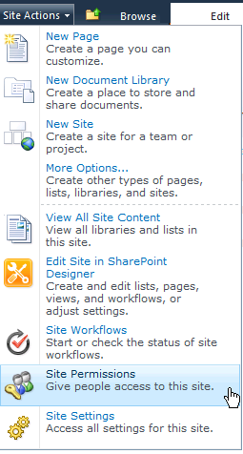

* 1. In the ribbon, click **Grant Permissions.**
  2. In the Users/Groups field, type **TedP.**
  3. Make sure that **Wingtip Product Management Members [Contribute]** is selected in the dropdown.
  4. Click **OK.**
  5. In the Ribbon, click **Grant Permissions.**
  6. Add **ScotH** to the **Wingtip Product Management Owners [Full Control]** group and click **OK.**

1. Upload some Top Secret documents.
2. Navigate back to the **Wingtip** **Product Management** home page.
   1. In the Quick Launch bar, click **Shared Documents.**
   2. In the Ribbon, click the **Documents** tab.
   3. In the Ribbon, click **Upload Document.**

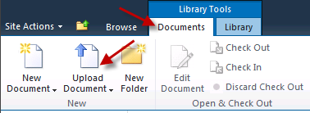

* 1. Click the **Browse** button.
  2. Navigate to [[Lab Files]]\Starter Files\.
  3. Select WingtipProductIdeas.docxand click **Open.**
  4. Click **OK** on the **Upload Document** window.
  5. Click **Save** on the Shared Documents – ProductIdeas.docx window.
  6. Repeat **Steps 3d – 3i** for the documents WingtipProductDetails.docxand WingtipProductTestResults.docx.

### Exercise 2: Back up the Product Management Site with PowerShell and SQL

1. Create a backup directory.
2. In **Windows Explorer**, navigate to the root of the C:\ drive.
   1. Make a new folder called SPBackups**.**
3. Use Windows PowerShell to back up the Product Management site.
4. Open the **SharePoint 2010 Management Console**.
   1. Type the following and press [Enter].

Backup-SPSite http://intranet.wingtip.com/sites/ProductManagement   
-path "C:\SPBackups\ProductManagement.bak"

* 1. Open up C:\SPBackups to verify that the backup completed.

1. Create a Database Snapshot in SQL.
2. Open **SQL Server Management Studio** by clicking **Start** » **All Programs** » **Microsoft SQL Server 2008** **R2**» **SQL Server Management Studio.**
   1. On the Connect to Server dialog box, click **Connect.**
   2. Expand the **Databases** tree .
   3. Scroll through the database list and find **WingtipIntranet_ContentDB**.
   4. Right-click on **WingtipIntranet_ContentDB** and select **New Query**.
   5. In the **Query** pane that opens, type the following script:

CREATE DATABASE WingtipIntranet_ContentDB_Snapshot   
ON (NAME = "WingtipIntranet_ContentDB",   
Filename = 'C:\SPBackups\WingtipIntranet_Snapshot.ss')  
AS SNAPSHOT OF "WingtipIntranet_ContentDB";

* 1. In the toolbar above the Query window, click the **Execute** button 
  2. Underneath the Query window, you will receive a message that the **Command** completed successfully.

1. Verify that the snapshot file exists.
2. In the **Object Explorer** pane in **SQL Server Management Studio**, expand the **Database Snapshots** folder and verify that **WingtipIntranet_ContentDB** exists there
   1. Open C:\SPBackups and verify that the WingtipIntranet_Snapshot.ss file exists.
   2. Switch back to the **Site Collection Documents** library in Internet Explorer.

### Exercise 3: Recover Deleted Information using Central Administration

Todd is being careless. While working in the Shared Documents folder, he accidentally deletes two of the product management documents. Then, while trying to recover the documents from the recycle bin, he ended up permanently deleting the documents. Todd is having a bad day.

1. Delete two documents.
2. Navigate to the document library named **Shared Documents**.
   1. Hover over the WingtipProductDetails.docxdocument and **check the box** that appears to the left.
   2. Hover over the WingtipProductTestResults.docxdocument and **check the box** that appears to the left.
   3. Click the **Delete** **Document** icon in the ribbon.

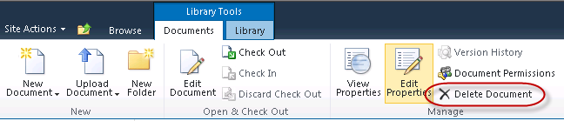

* 1. Click **OK** in at the prompt

Scot opens the library later and notices that the two documents are gone! He needs them quickly to finish up a Report for his manager and asks if there is anything you can do to recover them. Fortunately, you made a snapshot of the entire Wingtip Intranet content database just before Todd deleted the documents. You can recover the missing documents using that snapshot!

1. Use Central Administration to Browse the Database Snapshot.
2. Open **Central Administration**.
   1. Click **Backup and Restore.**
   2. Under the Granular Backup header, click **Recover data from an unattached content database.**



* 1. The **Database Server** should already be filled in with **WingtipServer.**
  2. For the **Database Name**, enter **WingtipIntranet_ContentDB_Snapshot**.
  3. In the **Choose Operation** section, keep **Browse Content** selected.

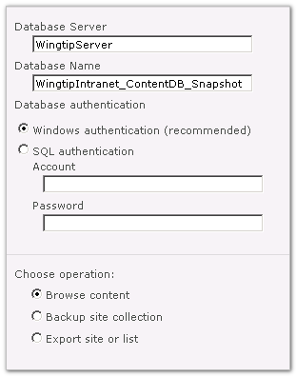

* 1. Click **Next**
  2. Click the dropdown next to **Site Collection**: and select **Change Site Collection**
  3. In the Select Site Collection window, select /sites/ProductManagementand click **OK.**
  4. Click the **Site:** dropdown and select **Change site**
  5. Select /sites/ProductManagement (it’s the only site available to choose from) and click **OK**.
  6. Click the **List:** dropdown and select **Change list**
  7. Page through the available lists and select **Shared Documents**, then click **OK.**
  8. Under **Choose operation**, select **Export Site or list.**
  9. Click **Next.**

1. Export the list to a file.
2. In the **Filename** field, type C:\SPBackups\ProductManagementSharedDocs.cmp.
   1. Click **Start Export.**
   2. The **Granular Backup Job Status** screen will appear and refresh every minute or so.
   3. When the **Status** under **Previous Job** in the **Content Export** section lists **Succeeded**, your export has finished.

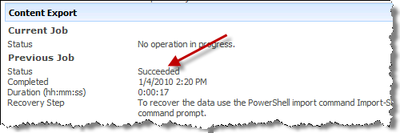

* 1. Notice also that this screen gives you a clue as to the next step in the recovery process

1. Import the list back into the **Wingtip Product Management** site for Scot.
2. Switch to your **SharePoint 2010 Management Shell** window.
3. Type the following cmdlet ad press [Enter].

Import-SPWeb

* 1. This cmdlet is prompting you for additional parameters. For **Identity**, type:

http://intranet.wingtip.com/sites/ProductManagement

* 1. For **Path**, type the following:

C:\SPBackups\ProductManagementSharedDocs.cmp

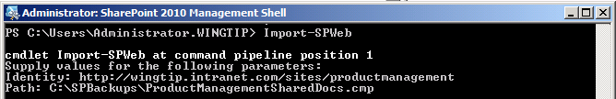

* 1. After a minute or so the backup will complete and will also let you know that a log file has been generated for the import.

1. Verify that the documents have been restored to the Shared Documents library.
2. In the browser, navigate to http://intranet.wingtip.com/sites/ProductManagement**.**
   1. Click **Shared Documents** in the **Quick Launch**.
   2. Notice that all the documents have been restored to the library.